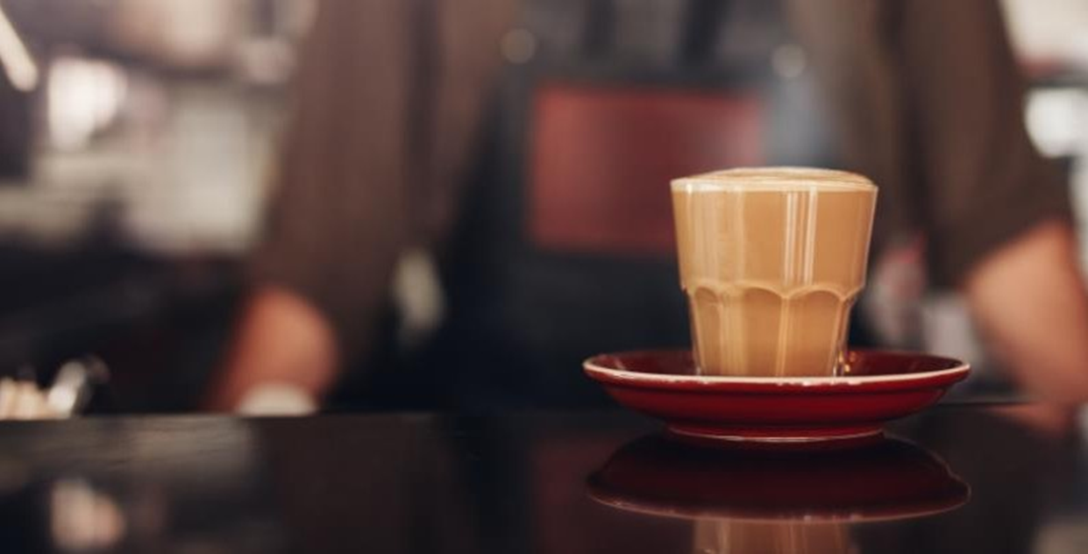
BUSINESS PLAN
BARRINGTON CAFE

63-79 Meron Street
Southport
QLD

Barrington Cafe' owners are taking advantage of the coffee house rage that has been sweeping the country. Along with taking advantage of this trend, they are also planning. Barrington Cafe is also marketing itself as a full-service restaurant to maintain stability, in case the coffee trend begins to fizzle.

- EXECUTIVE SUMMARY
- MISSION STATEMENT
- PURPOSE OF BUSINESS
- BUSINESS GOALS
- DESCRIPTION OF BUSINESS
- OPPORTUNITIES AND STRENGTHS
- CRITICAL RISKS AND PROBLEMS
- MARKETING
- OPERATIONS
- MANAGEMENT
- FINANCIAL

EXECUTIVE SUMMARY
The interest by consumers in the coffee house industry is sweeping the country. Barrington Cafe is positioned to bring this to the Gold Coast area. To date it has been confined to the Southport area.
Barrington Cafe will provide a friendly, comfortable atmosphere where the customer can receive quality food, service and entertainment at a reasonable price. The coffee house will offer a variety of choices to the customers. Coffee and tea of all sorts will be offered. Juice, soda, and non-alcoholic beverages also will be available. Barrington Cafe will serve breakfast, lunch and dinner.
The interior design of the building will focus on projecting a relaxed atmosphere. Barrington Cafe will be divided into different areas. Some will have tables and chairs, another will have large outdoor area with chairs, end tables, A PA system will be installed so that the music and entertainment can be heard throughout. A large selection of table games will be provided.
There will be nightly entertainment featuring acoustic jazz, blues and folk music. On selected nights there will be poetry readings and an open microphone. The walls will be used as an art gallery and from time to time there will be an artist in residence.
The site contains a 3,525 square foot building which was used as a sports bar and restaurant. The building has substantial parking. The site shares the Plaza with 6 other business. Remodelling will consist of removing the existing booths, new carpet and some new furniture. The kitchen and bathrooms will require only minimum remodelling. The property is currently zoned for restaurants.
The area comprising a three-kilometre radius around Barrington Cafe is heavily populated with young, upwardly, mobile persons with expendable income. This is complemented by many upper middle class "Baby Boomers" who are a large portion of those persons who frequent coffee houses.
A strength which this business will possess is the ability to change with the times. Rather than limiting the future opportunities by having a small area, Barrington Cafe will have 3,525 square feet of space and a kitchen designed for flexibility. As the fad of coffee houses fades, Barrington Cafe will be able to change to a full course restaurant or whatever the situation calls for.
The advertising and promotion will take several avenues. First, flyers will be distributed in the neighbourhood. Ads will be taken out in all of the Catholic church bulletins in the area. Since Barrington Cafe will be the first carbon neutral restaurant in the state, ads will be placed in all of the Greens newsletters. Ads will also be placed in the target areas of Grocery stores, and the local neighbourhood newsletters. For businesses in the area, menus will be distributed, and ordering will be available by App. A customer emailing list will be developed with a calendar of events being emailed monthly.
Barrington Cafe will be operated as a Sole Proprietorship. There will be private investors. However, these investors will be silent investors with a payoff of investment within three years. These investments will be paid twice-yearly in equal instalments including interest. The total needed capital for Barrington Cafe is $99,900. Owner's cash contribution is $10,000 and other investors and family members is $16,000. The amount needed in loans is $30,800 for equipment, $20,000 for remodelling, and $23,000 for operations. This is a total of $73,800.
Overall management will be the responsibility of the owner. The owner brings to the business over 20 years of business experience including over five years in restaurant management and five years in directing a multifaceted non-profit housing program. The general manager will have a minimum of 10 years’ experience. A major emphasis of Barrington Cafe will be to hire economically disadvantaged or at-risk persons and provide them with job training. The majority of these persons will be identified through the Southport Training Partnership.

VISION STATEMENT
We strive to maintain the highest of quality in service and dining experience!

MISSION STATEMENT
To provide a friendly, comfortable atmosphere where the customer can receive quality food, service, and entertainment at a reasonable price.
Barrington Cafe strives to provide the freshest roasted coffee beans, the best cakes and biscuits, with exceptional customer service. Barrington Cafe always puts our customers first, as they are the highest priority.

PURPOSE OF BUSINESS PLAN
This document is intended to outline the start-up of the business known as Barrington Cafe. The business plan has a two-fold mission. One is to obtain financing. The other is to help define the who, what, where, when and how for the business so that the business will have a clear-cut plan and operations map.

BUSINESS GOALS
The goals of the business are to provide a substantial income and to create a business and working environment where both the customer and employee are treated with dignity and respect.
The specific goals of the business are:
Profit - personal income in excess of $50,000 per year within three years
Clientele - create a base clientele of persons who live and work in the area. These persons will like a relaxed atmosphere where they can "hang out"
Employees - Competent employees (at least 51% from low-income neighbourhoods) who are committed and loyal

DESCRIPTION OF BUSINESS
Barrington Cafe will be a coffee house/restaurant located in the Mercoto on Fairy shopping Mall, Cnr Meron street and Fairy Road.
The coffee house will offer a variety of choices to the customers. Coffee and tea of all sorts will be offered. The choices of coffee will range from espresso to latte, from regular flavour to raspberry-mocha. The teas will range from English to flavoured varieties.
Juice, soda, and non-alcoholic beverages also will be available. For those who want something else to drink, health conscious smoothies.
The breakfast menu will feature croissants, muffins, bagels, donuts, French pastries, fruit filled crepes, etc. Except for the crepes, the baked goods will be purchased. Lunch and dinner will feature sandwiches, salads and seven different soups. In hot weather, a variety of cold soups will be offered. In addition, Barrington Cafe will feature a vast array of appetizers. These will include artichokes (Both stuffed or served with butter); stuffed mushrooms; mini loaves of bread served with your choice of a bowl of pesto, queso, or green chile, etc. Desserts will consist of cheesecakes (some fat-free), pastries, pies, fresh fruit and cheese.
The design of the building will focus on projecting a relaxed atmosphere. The outdoor patio styled cafés bottom portion of the wall will be tiled with faux greenery with the upper being open planned café windows. Fresh herb garden that will be used in the café to enhance dishes. The outdoor carpeting will be forest green. The chairs will be plastic and colourful stools will also be used. The tablet will be all timber and galvanised round tabletops. Plants will abound in black planters. The dishes and eating utensils will be environmentally friendly and one use only due to Covid-19. The coffee cups will be the same as the eating utensils.
Barrington Cafe will be divided into different areas. An advantage to having different areas is that customers can partake in different activities without bothering anyone (i.e., political discussions will not interfere with the music, or the music will not interfere with those playing board games or reading).
The emphasis will be on providing a comfortable environment for the customer where they will want to linger and return many times.

OPPORTUNITIES AND STRENGTHS
The time is right for opening a coffee house in Southport. Coffee houses are having a great deal of success, which is evidenced by the full houses every day of the week. The Southport area has no such places. The closest competition is the Coffee Club located at Mercoto on Fairy shopping Mall, Cnr Meron street and Fairy Road.
. To reach a coffee house, a customer from our area must drive 20 to 30 minutes. Most of these establishments are located on the South side of town. A few are beginning to open in the downtown area.
The area comprising a three-kilometre radius around Barrington Cafe is heavily populated with young, upwardly, mobile persons with expendable income. This is complimented by many upper middle classes "Baby Boomers" who are a large portion of those persons who frequent coffee houses.
An additional strength which this business will possess is the ability to change with the times. Rather than limiting the future opportunities by having a small area, Barrington Cafe will have 3,525 square feet of space. The kitchen will be designed for flexibility. As the fad of coffee fades, Barrington Cafe will be able to change to a full course restaurant or whatever the situation calls for.
The business will bring with it a strong group of persons with an extensive background in both restaurants and business.

CRITICAL RISKS AND PROBLEMS
There are risks inherent with any business. However, the restaurant business carries with it very unique risks. Most critical is the customers' changing tastes. Another is the economy. Restaurants rely heavily on serving persons who have expendable income. When the economy takes a downturn, people change their spending priorities. There are less trips to restaurants.
A problem also in restaurants is finding dependable help who will stay with the business. Many restaurant employees tend to be younger and are attempting to move into a career. When either their schooling ends or they find their "dream job," they move on. Often servers filling the positions are non-skilled and tend to be single mothers or lower educated persons. These persons come with specific circumstances which must be accounted for by management. A single mother may experience child-care problems, or a bus person may have problems with reading. A good owner must learn to deal with these problems in a manner which benefits the business as well as the employee.

MARKETING

Goal
Generate monthly sales revenues of $71,000 per month of 3% of the target market within 18 months of opening.

Objectives
- Maintain a high standard of food quality and service
- Provide first-rate live entertainment without a cover charge
- Ensure a friendly comfortable atmosphere
- Place monthly ads in neighbourhood publications
- Distribute monthly fliers to neighbourhood, businesses, and churches
- Offer discount coupons
- Maintain and use a customer emailing list

Target Customer
The customer will be between 18 to 55 years old. The income level is between $20,000 and $100,000 per year. They will live within three-kilometre of Barrington Cafe. They will be white collar workers (managers, professionals, etc.) with expendable income. The education level will range from some college to post-graduate work. A limited number (10%) will come from other areas. This 10% will generally be persons who are coming to see a particular entertainer or poetry reading. A majority of the customers will be persons who enjoy a relaxing atmosphere, conversation and table games.

Estimated Market Share and Sales
Based on the customer profile for Barrington Cafe the following numbers were compiled. The report used was prepared by Gauder Real Estate using information obtained through the Facts Report. The report was prepared using Barrington Cafe as the focal point and delineating numbers by a one, three- and five-kilometre radius. For purposes of determining market share for Barrington Cafe, a three-kilometre radius was used. National statistics show that most persons do not travel more than three-kilometre to eat or to listen to entertainment. The report shows that 162,908 persons live in the three-kilometre radius. The following is the breakdown of target customers.
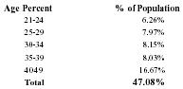
Age Percent | % of Population
21-24 | 6.26%
25-29 | 7.97%
30-34 | 8.15%
35-39 | 8.03%
4049 | 16.67%
Total | 47.08%
Income | % of Population
50,000-74,999 | 20.94%
35,000-49,999 | 20.04%
25,000-34,999 | 14.92%
Total | 55.90%
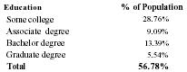
Education | % of Population
Some college | 28.76%
Associate degree | 9.09%
Bachelor degree | 13.39%
Graduate degree | 5.54%
Total | 56.78%
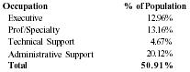
Occupation | % of Population
Executive | 12.96%
Prof/Specialty | 13.16%
Technical Support | 4.67%
Administrative Support | 20.12%
Total | 50.91%

Formula for Market Share
The formula takes the total population and then multiplies that number by the percentages in order of importance to the Target Customer.
Total Population × Age% × Income% × Education% × Occupation% = Total Market
162,908×47.08%×55.90%×56.78%×50.91% = 12,393 persons
Market Share For Barrington Cafe
2.2% Of Market=276 Cust./Day or 17 Cust./Hour
1.8% Of Market=230 Cust./Day or 14 Cust./Hour
1.6% Of Market=202 Cust./Day or 12 Cust./Hour

Occupancy Levels
The occupancy of Barrington Cafe is 127 persons. Two different methods can be used to determine occupancy levels.
Hourly - If you estimate percent of occupancy on an hourly basis, the customer rate would be 9.4% of occupancy. 12 cust/hr /127 = 9.4% occupancy per hour
Mealtime - Typically, you will have two turnovers per meal. Based on projections the percentages would be 23% for breakfast, 27% for lunch and 32% for dinner.
Breakfast - 57 cust/2 = 29 cust/127 = 23% occupancy level
Lunch - 67 cust/2 = 34 cust/127 = 27% occupancy level
Dinner - 79 cust/2 = 40 cust/127 = 32% occupancy level
In reality, the true occupancy rate lies somewhere in the middle. Not all of the customers will come in during those dinner times nor will they be spaced evenly throughout the day.

Promotion & Advertising
The advertising and promotion will take several avenues. First, flyers will be distributed in the neighbourhood. Ads will be taken out in all of the Church bulletins in the area. These ads will offer 10% off, if the parishioner brings the bulletin with them. The restaurant is located one block from a Church and school. The owner's family attend the church and have a son who has been a student in the school for 7 years. Special events will be promoted with a portion of the proceeds going to the school. Since Barrington Cafe will be the first carbon neutral restaurant in the state, ads will be placed in all of the carbon neutral newsletters offering a 10% discount to anyone showing their carbon neutral card. Ads will also be placed in the target areas of the Grocery stores, and the local neighbourhood newsletters. For special entertainment nights, radio and newspaper ads will be placed. Entertainment and food critics will be given an invitation. On opening night, we will have an invitation only party, with over 1,200 invitations being sent.
For businesses in the area, menus will be distributed, and ordering will be available by app. A customer emailing list will be developed with a calendar of events being emailed on a monthly basis.

Sales Tactics
Servers will always ask the customer if they want added items, i.e. specialty coffee, soup with the sandwich, appetizers, and dessert. This will increase sales for the business..
All tables also will have "table tents" or advertisements. The tents will describe upcoming events. Also, pictures and descriptions of items for sale, such as healthy smoothies, desserts, etc., will be on the tents. The menus will provide detailed descriptions of the items available, including a section describing the different types of coffees, smoothies available. For example, the Vegan smoothies.

Service/Warranty
If the customer has a complaint, everything will be done to satisfy them. If that does not work, the customer will be given their meal free of charge.

Competition
Sushi Train – Also in the same venue is opened from 10 am to 8pm for sushi style meals. Soft drinks and teas are also served.
Raw Espresso Cafe – Same venue and serving coffee and other beverages similar to us. Meals are takeaway and mainly sandwiches and salads. Opening hours are 6am to 2pm Pricing is on the higher end of the market.
Furbilicious Kebebs – Same venue. Lunch and afternoon trading only with kebab and salad style meals. Hot chips and soft drinks. No coffees.
Crispy Fried chicken- Same venue. Deep fried chicken burgers, chips, soft drinks. Opening hours 10 -9pm More to the not so healthy range of foods.
Ramen Danbo Japanese cuisine no coffee and only dine in from 5pm to late.

OPERATIONS

Goals
Keep cost of goods sold at or below 30%. Provide customers with prompt and courteous service.

Objective
- Provide initial training for all employees
- Hold monthly employee meetings
- Have an open-door policy for employee suggestions and concerns
- Implement the use of the Business Plan systems
- Purchase and use a food software package
- Have clearly defined job descriptions and duties
- Have an employee policy handbook
- Do employee reviews every six months
- Customer suggestion box
- Design kitchen and service area to be efficient

Product Distribution
The product will be distributed in the restaurant by food servers. The food will be cooked on site, except for some of the baked goods. Some of these, such as croissants will be purchased in the raw frozen form and baked daily.
When a customer enters Barrington Cafe they will be greeted by a hostess who will seat them and provide them with menus. A server will greet them and give them water. The server will inquire what they would like to drink. The drink order will be prepared by the server. If the drink is either soft drink, smoothie or coffee, that will be prepared by the bartender. The drink order will be given to the bartender on a written check, which will be rung up on the register. If the server fixed the drink, it will be rung up on the register by the server. The server will deliver the drinks and then take the food order if the customer is ready. The server will take the food order, ring it up and the order will appear on the cook's computer screen. The cook will prepare the food, in the order the tickets are given. The server will prepare the salads, desserts, hot and cold soups and other items. The cook places the finished food on the window. The server must pick the food up within two minutes. The food is placed on the table and the server will ask if there is anything else which the customer needs. The server will check all the drinks and replenish water, iced tea and plain coffee. The server will ask if the customer needs another drink. Specialty drinks are not refill items. Non-specialty drinks are free refills. The server will familiarize the customer with the operations of Barrington Cafe. They will explain to the customer that a number of table games are available if they wish to play. The server will let the customer know about the reading room and present them with a schedule of events. The customer will always be asked if they would like dessert or an after-dinner coffee. The server is responsible for checking on the customer in a timely manner. This should be done in an unobtrusive manner. The server will maintain the tables in a clean and sanitary condition. Dirty dishes and plates must be removed immediately. Condiments must be kept full and the containers clean. The server is responsible for presenting the check, payment of the check and returning a receipt to the customer.
The cook is responsible for cooking and preparing all dishes not prepared by the server. The orders will appear on the computer monitor and the cook will prepare them according to the order given. The cook and their assistants are responsible for preparing all items in the morning such as the soups for the day, slicing meat, making specialty items and other dishes for the day. The assistant cooks are responsible for the prep work of all items for the servers and the cooks. This includes stocking all supplies, cutting cheese, fruit, salad items, ice, filling soup tureens, etc.
Cleanliness is required above all else. The servers will keep all their work areas clean at all times. Spills must be cleaned immediately. After each shift, servers will check the side work chart, and have it finished before they leave. This work will be checked by the shift supervisor. The cooking area will be maintained in a clean and sanitary manner. All areas will routinely be wiped down and swept. The cooks and assistants will also have side work which must be completed before leaving. The dishwasher is responsible for keeping the dishes washed and helping with busing the tables if needed. The dishwasher is responsible for mopping the kitchen floor. All employees must read and be knowledgeable of health regulations and follow those rules. Training will be provided by Barrington Cafe. Hands must be washed on a routine basis. Barrington Café is a non-smoking facility.
The servers will be required to present a clean appearance. A uniform consisting of an eggshell white polo shirt with Barrington Cafe logo, black long pants, black sneakers and black ankle socks. The servers must be polite, friendly, and helpful, not only to the customer but to the other staff as well. At no time will employees be allowed to discriminate by remarks, actions or jokes.
Additional regulations are contained in the Employee Handbook.

Cash Register
The cash register system will be Square. The built-in system software prints hard or soft guest checks, uses single or multiple remote printers, and reports and tracks data terminal to terminal, or throughout the network. Produces management reports for system, terminal, or revenue centre; current and/or to-date totals for:
- Employee/cashier balance reports
- Employee tip reports
- Open and closed check reports
- Time period sales analysis
- Detailed or summarized menu item sales analysis
- Detailed or summarized sales group and category analysis

Pricing
The food price will be in the moderate range and comparable to other coffee houses in the area. The cost will be determined by not only what the going rate in the area is but also by the percentage of actual cost of the food. The price will not only be competitive, but the food will be tasty, well presented, and large portions will be served in a relaxing atmosphere where the customer will be comfortable. The image projected by the pricing will be that the customer will be getting a fair value for their money; that they do not need to be rich to eat at Barrington Cafe and anyone can afford to come in. They will be able to use the books and games. In the evening, they will be able to listen to the live entertainment. During the day, music will be played over the PA.
Credit terms will be offered only in the form of credit card service, such as Visa, MasterCard. Many people who eat out prefer to pay with credit cards, whether it is to keep track of expenditures or for a work expense account.
The cost of the food will be based on a set percentage. Restaurants traditionally keep food costs between 26% to 32%. Based on the type of food to be served and the delivery system, the percentage for Barrington Cafe will be an average of 30% of the actual cost of the food. In order to accomplish this, Food costing software will be utilized. The software contains the following features.

Inventory Accounting System
Calculates cost of goods, provides shelf-order inventory forms, receiving logs, compares actual usage to average usage by item, ranks highest over and under use items. Tracks vendors allows look-up by name or vendor item codes. Automatic distribution of invoice amounts to general ledger account numbers. Purchase and transaction recap reports, inventory level control reports, price history and fluctuation reports.

Recipe Costing and Sizing
Plate and batch recipes instantly costed as prices change. Sizing and modelling capabilities.

Menu Analysis
Complete menu and sales analysis reporting. Evaluate menu performance, run products by contribution. Product cost reports available by day or any combination of days. Sales mix can be sequenced to follow "Z" tape order for fast data entry.

Ideal Use/Perpetual Inventory
Tightest possible method of inventory control compares actual use to ideal use by item and computes variance. Includes ability to run perpetual inventories and track batch recipe production variances.

Bid and Purchase Order
Built-in bid pricing system allows entry of vendor bids and automatic selection of best price available. Shopping list feature, automatic PO creation, price history reports and more.

POS Interface
Import sales mix data directly from almost any cash register. POS system or polling package.

Accounts Payable Interfaces
Export purchases to accounts payable system.

Suppliers
Norco Milk
PFD
City to country
Campbells
Costco

MANAGEMENT

Goal
To have a competent and knowledgeable management staff which functions as a team.

Objectives
- Hire experienced, qualified persons
- Conduct weekly management meetings
- On-going training to include outside classes in food service, management, etc.
- Reviews every six months
- Performance incentives
- Encourage creativity

Organisation
Barrington Cafe will be operated as a Sole Proprietorship. There will be private investors. However, these investors will be silent investors with a payoff of investment within three years. These investments will be paid twice-yearly in equal instalments including interest.
Overall management will be the responsibility of the owner. There will be a general manager and shift supervisors.

Proprietor
As owner, Colleen Gauder brings to Barrington Cafe an extensive and varied background. She has been General Manager for two restaurants and has been the Dining Room Manager for a major private club.
Her most recent experience was with a non-profit agency. She was responsible for overseeing three housing programs for the agency and a staff of six persons. Her duties included: monthly reports to Barrington Australia, City of Southport and State Housing Trust Fund; over a $500,000 yearly budget. Colleen is competent in all areas regarding regulations for the above-mentioned organisations, and other government programs.
Also, she performed the grant writing, and was responsible for fundraising and public speaking on behalf of the agency. She worked closely with the Executive Director on purchases of properties for affordable rental from Barrington Australia Properties and also wrote the Barrington Australia Properties monitoring reports.
In addition, she helped case-work clients, advocated for low-income persons, performed housing counselling for persons in danger of foreclosure and worked with carbon neutral members in need of services.

General Manager

Qualifications
This position has not been filled. The requirements of the position require 10 years’ experience in restaurants, at least five of those years in some type of supervisory position. A bachelor's degree in hotel and restaurant management is preferable. The candidate for this position will be required to submit a resume and verifiable references. The candidate will be interviewed and hired by the proprietor.

Job Description
The general manager will report directly to the owner. They will be responsible for the overall management of the staff. They will work in conjunction with the owner in ordering supplies, maintaining inventory, handling customer complaints and scheduling staff. Other duties would include ensuring staff coverage for all shifts and reports to the owner.

Shift Supervisor

Qualifications
Must have five years’ experience in restaurant work. At least three years as a server. They must be at least 21 years old. They must possess a friendly and outgoing personality and have good personal hygiene.
The candidate for this position will be required to submit a resume and applications.
The candidate will be interviewed and hired by the proprietor and general manager.

Job Description
They will be responsible for the oversight of the servers, bus person and hostess on their shift. They will work under the general manager.
The shift supervisor also works in the capacity of a server and is responsible for waiting on tables, taking the customers' food and drink orders and acting as cashier for their customers. They are responsible for helping to keep the serving area and the customer areas clean and sanitary. They are responsible for helping the assistant cook keep the service area stocked. At the end of their shift, they will be required to complete all side work as assigned.

Cook

Qualification
The cooks must have a minimum of five years’ experience, three of which must be as a cook not an assistant. They must have at a minimum a high school certificate or Cert III Commercial Cookery.
The cook will submit a resume and fill out an application. They will be interviewed and hired by the owner and general manager.

Job Description
The cook is responsible for cooking food served in the restaurant. They also are responsible for preparing food items in advance and seeing that the service area is kept stocked. Their responsibility is to see that the kitchen is kept in a clean, sanitary, and working order. They oversee and train the assistant cook.

Assistant Cook

Qualifications
The assistant cook must at a minimum have a QCE or be attending school or a training program. They must be at least 18 years of age.
Will be required to submit an application. Will be interviewed and hired by the cook, general manager and owner.

Job Description
The assistant cook is responsible for assisting the cook in his duties. He/she is responsible for helping to keep the kitchen clean and sanitary. When needed will help with dishwashing duties. He/she is responsible for keeping the service area stocked.

Server

Qualification
The servers must have at a minimum a QCE or be attending school or a training program and one year's experience working in a restaurant. They must be at least 18 years of age. They must possess a friendly and outgoing personality and have good personal hygiene.
Will be required to submit an application. Will be interviewed and hired by the shift supervisor, general manager and owner.

Job Description
The server is responsible for waiting on tables, taking the customers' food and drink orders and acting as cashier for their customers. They are responsible for helping to keep the serving area and the customer areas clean and sanitary. They are responsible for helping the assistant cook keep the service area stocked. At the end of their shift, they will be required to complete all side work as assigned.

Hostess

Qualifications
The hostess must have at a minimum a QCE or be attended school or a training program. She must be at least 18 years of age and must possess a friendly and outgoing personality and have good personal hygiene.
Will be required to submit an application. Will be interviewed and hired by the shift supervisor, general manager and owner.

Job Description
The hostess is responsible for greeting customers as they arrive at the restaurant and seating them. She is required to take reservations and answer the phones. Also to assist with busing tables or assisting the servers when available. Duties include keeping the lobby area clean.

Bus Person

Qualifications
The bus person must be attending school or a training program, must be at least 16 years of age and have good personal hygiene.
Will be required to submit an application. Will be interviewed and hired by the shift supervisor, general manager and owner.

Job Description
The bus person is responsible for keeping dirty dishes off the tables. When customers leave they must clean the table and prepare it for future customers. They are to help the servers with getting non-alcoholic drinks. They also are responsible for helping the servers. They are responsible for helping the assistant cook keep the service area stocked. At the end of their shift, they will be required to complete all side work as assigned.

FINANCIAL
To maintain costs of goods sold to 30% or less. To increase sales within an 18 month period to 3% of the target market. To maintain financial records according to GAAP.

Goals

Objectives
- Purchase and use Food Fax software
- Train employees proper food handling to prevent waste
- Maintain a weight and portioning system for food
- Check for quality of food from suppliers when food is delivered
- Maintain storage equipment in proper working condition
- Hire an experienced and qualified accounting firm
- Contract out payroll
- Purchase a personnel computer
- Utilize Business Plan equipment Use Accounting software

Financing Plan and Exit Strategy
The total needed capital for Barrington Cafe is $100,000. Owner's cash contribution is $10,000 and other investors and family members is $16,100. The amount needed in loans is $30,800 for equipment, $20,000 for remodelling, and $23,000 for operations. This is at total of $73,800.
An acceptable exit strategy for Barrington Cafe is to sell the business to another company. The restaurant business is booming on the Gold Coast.
The least desirable plan would be to sell the equipment, furniture and other assets. The remaining balance would have to be renegotiated and a payment plan worked out.

Advertising Schedule
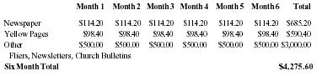
 | Month 1 | Month 2 | Month 3 | Month 4 | Month 5 | Month 6 | Total
Newspaper | $114.20 | $114.20 | $114.20 | $114.20 | $114.20 | $114.20 | $685.20
Yellow Pages | $98.40 | $98.40 | $98.40 | $98.40 | $98.40 | $98.40 | $590.40
Other | $500.00 | $500.00 | $500.00 | $500.00 | $500.00 | $500.00 | $3,000.00
Fliers, Newsletters, Church Bulletins
Six Month Total |  |  |  |  |  |  | $4,275.60

Cost Analysis
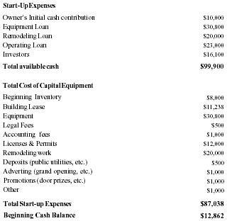
Start-Up Expenses
Owner's Initial cash contribution | $10,000
Equipment Loan | $30,800
Remodeling Loan | $20,000
Operating Loan | $23,000
Investors | $16,100
Total available cash | $99,900
Total Cost of Capital Equipment
Beginning Inventory | $8,000
Building Lease | $11,238
Equipment | $30,800
Legal Fees | $500
Accounting fees | $1,000
Licenses & Permits | $12,000
Remodeling work | $20,000
Deposits (public utilities, etc.) | $500
Adverting (grand opening, etc.) | $1,000
Promotions (door prizes, etc.) | $1,000
Other | $1,000
Total Start-up Expenses | $87,038
Beginning Cash Balance | $12,862

Capital Equipment
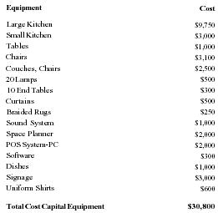
Equipment | Cost
Large Kitchen | $9,750
Small Kitchen | $3,000
Tables | $1,000
Chairs | $3,100
Couches, Chairs | $2,500
20 Lamps | $500
10 End Tables | $300
Curtains | $500
Braided Rugs | $250
Sound System | $1,000
Space Planner | $2,000
POS System-PC | $2,000
Software | $300
Dishes | $1,000
Signage | $3,000
Uniform Shirts | $600
Total Cost Capital Equipment | $30,800

Mortgage Schedule
Principal | 73,800.00
Interest | 10.750%
# of Periods | 120
Yearly Payment | 12,074.15
Monthly Payment | 1,006.18
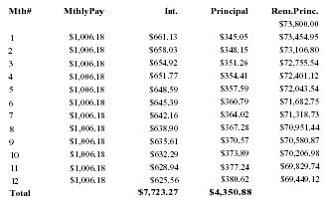
Mth# | Mthly Pay | Int. | Principal | Rem. Prince.
 |  |  |  | $73,800.00
1 | $1,006.18 | $661.13 | $345.05 | $73,454.95
2 | $1,006.18 | $658.03 | $348.15 | $73,106.80
3 | $1,006.18 | $654.92 | $351.26 | $72,755.54
4 | $1,006.18 | $651.77 | $354.41 | $72,401.12
5 | $1,006.18 | $648.59 | $357.59 | $72,043.54
6 | $1,006.18 | $645.39 | $360.79 | $71,682.75
7 | $1,006.18 | $642.16 | $364.02 | $71,318.73
8 | $1,006.18 | $638.90 | $367.28 | $70,951.44
9 | $1,006.18 | $635.61 | $370.57 | $70,580.87
10 | $1,006.18 | $632.29 | $373.89 | $70,206.98
11 | $1,006.18 | $628.94 | $377.24 | $69,829.74
12 | $1,006.18 | $625.56 | $380.62 | $69,449.12
Total |  | $7,723.27 | $4,350.88
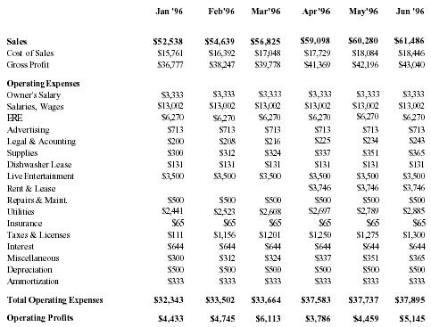
Projected Income Statement For Year Ending December 31, 1996
 | Jan '96 | Feb '96 | Mar '96 | Apr '96 | May '96 | Jun '96
Sales | $52,538 | $54,639 | $56,825 | $59,098 | $60,280 | $61,486
Cost of Sales | $15,761 | $16,392 | $17,048 | $17,729 | $18,084 | $18,446
Gross Profit | $36,777 | $38,247 | $39,778 | $41,369 | $42,196 | $43,040
Operating Expenses
Owner's Salary | $3,333 | $3,333 | $3,333 | $3,333 | $3,333 | $3,333
Salaries, Wages | $13,002 | $13,002 | $13,002 | $13,002 | $13,002 | $13,002
ERE | $6,270 | $6,270 | $6,270 | $6,270 | $6,270 | $6,270
Advertising | $713 | $713 | $713 | $713 | $713 | $713
Legal & Acounting | $200 | $208 | $216 | $225 | $234 | $243
Supplies | $300 | $312 | $324 | $337 | $351 | $365
Dishwasher Lease | $131 | $131 | $131 | $131 | $131 | $131
Live Entertainment | $3,500 | $3,500 | $3,500 | $3,500 | $3,500 | $3,500
Rent & Lease |  |  |  | $3,746 | $3,746 | $3,746
Repairs & Maint. | $500 | $500 | $500 | $500 | $500 | $500
Utilities | $2,441 | $2,523 | $2,608 | $2,697 | $2,789 | $2,885
Insurance | $65 | $65 | $65 | $65 | $65 | $65
Taxes & Licenses | $111 | $1,156 | $1,201 | $1,250 | $1,275 | $1,300
Interest | $644 | $644 | $644 | $644 | $644 | $644
Miscellaneous | $300 | $312 | $324 | $337 | $351 | $365
Depreciation | $500 | $500 | $500 | $500 | $500 | $500
Ammortization | $333 | $333 | $333 | $333 | $333 | $333
Total Operating Expenses | $32,343 | $33,502 | $33,664 | $37,583 | $37,737 | $37,895
Operating Profits | $4,433 | $4,745 | $6,113 | $3,786 | $4,459 | $5,145
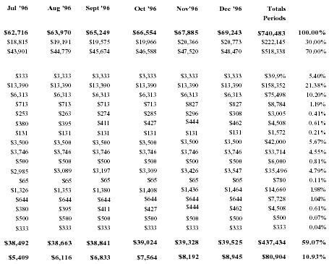
Jul '96 | Aug '96 | Sept '96 | Oct '96 | Nov '96 | Dec '96 | Totals Periods
$62,716 | $63,970 | $65,249 | $66,554 | $67,885 | $69,243 | $740,483 | 100.00%
$18,815 | $19,191 | $19,575 | $19,966 | $20,366 | $20,773 | $222,145 | 30.00%
$43,901 | $44,779 | $45,674 | $46,588 | $47,520 | $48,470 | $518,338 | 70.00%
$333 | $3,333 | $3,333 | $3,333 | $3,333 | $3,333 | $39,9% | 5.40%
$13,390 | $13,390 | $13,390 | $13,390 | $13,390 | $13,390 | $158,352 | 21.38%
$6,313 | $6,313 | $6,313 | $6,313 | $6,313 | $6,313 | $75,498 | 10.20%
$713 | $713 | $713 | $713 | $827 | $827 | $8,784 | 1.19%
$253 | $263 | $274 | $285 | $296 | $308 | $3,005 | 0.41%
$380 | $395 | $411 | $427 | $444 | $462 | $4,508 | 0.61%
$131 | $131 | $131 | $131 | $131 | $131 | $1,572 | 0.21%
$3,500 | $3,500 | $3,500 | $3,500 | $3,500 | $3,500 | $42,000 | 5.67%
$3,746 | $3,746 | $3,746 | $3,746 | $3,746 | $3,746 | $33,714 | 4.55%
$500 | $500 | $500 | $500 | $500 | $500 | $6,000 | 0.81%
$2,985 | $3,089 | $3,197 | $3,309 | $3,426 | $3,547 | $35,496 | 4.79%
$65 | $65 | $65 | $65 | $65 | $65 | $780 | 0.11%
$1,326 | $1,353 | $1,380 | $1,408 | $1,436 | $1,464 | $14,660 | 1.98%
$644 | $644 | $644 | $644 | $644 | $644 | $7,728 | 1.04%
$380 | $395 | $411 | $427 | $444 | $462 | $4,508 | 0.61%
$500 | $500 | $500 | $500 | $500 | $500 | $500 | 0.07%
$333 | $333 | $333 | $333 | $333 | $333 | $333 | 0.04%
$38,492 | $38,663 | $38,841 | $39,024 | $39,328 | $39,525 | $437,434 | 59.07%
$5,409 | $6,116 | $6,833 | $7,564 | $8,192 | $8,945 | $80,904 | 10.93%
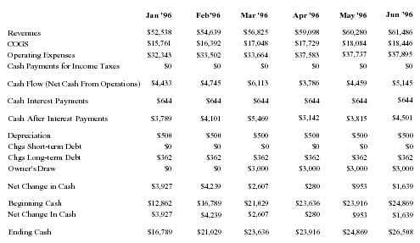
Projected Statement of Cash Flow For Year Ending December 31, 1996
 | Jan '96 | Feb'96 | Mar '96 | Apr '96 | May '96 | Jun '96
Revenues | $52,538 | $54,639 | $56,825 | $59,098 | $60,280 | $61,486
COGS | $15,761 | $16,392 | $17,048 | $17,729 | $18,084 | $18,446
Operating Expenses | $32,343 | $33,502 | $33,664 | $37,583 | $37,737 | $37,895
Cash Payments for Income Taxes | $0 | $0 | $0 | $0 | $0 | $0
Cash Flow (Net Cash From Operations) | $4,433 | $4,745 | $6,113 | $3,786 | $4,459 | $5,145
Cash Interest Payments | $644 | $644 | $644 | $644 | $644 | $644
Cash After Interest Payments | $3,789 | $4,101 | $5,469 | $3,142 | $3,815 | $4,501
Depreciation | $500 | $500 | $500 | $500 | $500 | $500
Chgs Short-term Debt | $0 | $0 | $0 | $0 | $0 | $0
Chgs Long-term Debt | $362 | $362 | $362 | $362 | $362 | $362
Owner's Draw | $0 | $0 | $3,000 | $3,000 | $3,000 | $3,000
Net Change in Cash | $3,927 | $4,239 | $2,607 | $280 | $953 | $1,639
Beginning Cash | $12,862 | $16,789 | $21,029 | $23,636 | $23,916 | $24,869
Net Change In Cash | $3,927 | $4,239 | $2,607 | $280 | $953 | $1,639
Ending Cash | $16,789 | $21,029 | $23,636 | $23,916 | $24,869 | $26,508
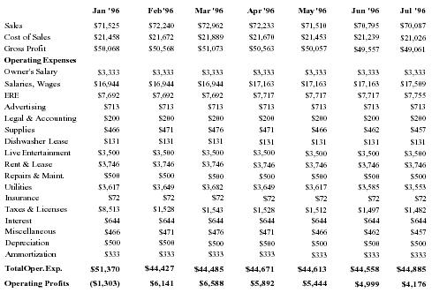
Projected Income Statement For Year Ending December 31, 1997
 | Jan '96 | Feb'96 | Mar '96 | Apr '96 | May '96 | Jun '96 | Jul '96
Sales | $71,525 | $72,240 | $72,962 | $72,233 | $71,510 | $70,795 | $70,087
Cost of Sales | $21,458 | $21,672 | $21,889 | $21,670 | $21,453 | $21,239 | $21,026
Gross Profit | $50,068 | $50,568 | $51,073 | $50,563 | $50,057 | $49,557 | $49,061
Operating Expenses
Owner's Salary | $3,333 | $3,333 | $3,333 | $3,333 | $3,333 | $3,333 | $3,333
Salaries, Wages | $16,944 | $16,944 | $16,944 | $17,163 | $17,163 | $17,163 | $17,509
ERE | $7,692 | $7,692 | $7,692 | $7,717 | $7,717 | $7,717 | $7,755
Advertising | $713 | $713 | $713 | $713 | $713 | $713 | $713
Legal & Accounting | $200 | $200 | $200 | $200 | $200 | $200 | $200
Supplies | $466 | $471 | $476 | $471 | $466 | $462 | $457
Dishwasher Lease | $131 | $131 | $131 | $131 | $131 | $131 | $131
Live Entertainment | $3,500 | $3,500 | $3,500 | $3,500 | $3,500 | $3,500 | $3,500
Rent & Lease | $3,746 | $3,746 | $3,746 | $3,746 | $3,746 | $3,746 | $3,746
Repairs & Maint. | $500 | $500 | $500 | $500 | $500 | $500 | $500
Utilities | $3,617 | $3,649 | $3,682 | $3,649 | $3,617 | $3,585 | $3,553
Insurance | $72 | $72 | $72 | $72 | $72 | $72 | $72
Taxes & Licenses | $8,513 | $1,528 | $1,543 | $1,528 | $1,512 | $1,497 | $1,482
Interest | $644 | $644 | $644 | $644 | $644 | $644 | $644
Miscellaneous | $466 | $471 | $476 | $471 | $466 | $462 | $457
Depreciation | $500 | $500 | $500 | $500 | $500 | $500 | $500
Ammortization | $333 | $333 | $333 | $333 | $333 | $333 | $333
Total Oper. Exp. | $51,370 | $44,427 | $44,485 | $44,671 | $44,613 | $44,558 | $44,885
Operating Profits | ($1,303) | $6,141 | $6,588 | $5,892 | $5,444 | $4,999 | $4,176
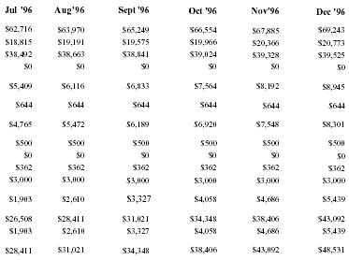
Jul '96 | Aug '96 | Sept '96 | Oct '96 | Nov '96 | Dec '96
$62,716 | $63,970 | $65,249 | $66,554 | $67,885 | $69,243
$18,815 | $19,191 | $19,575 | $19,966 | $20,366 | $20,773
$38,492 | $38,663 | $38,841 | $39,024 | $39,328 | $39,525
$0 | $0 | $0 | $0 | $0 | $0
$5,409 | $6,116 | $6,833 | $7,564 | $8,192 | $8,945
$644 | $644 | $644 | $644 | $644 | $644
$4,765 | $5,472 | $6,189 | $6,920 | $7,548 | $8,301
$500 | $500 | $500 | $500 | $500 | $500
$0 | $0 | $0 | $0 | $0 | $0
$362 | $362 | $362 | $362 | $362 | $362
$3,000 | $3,000 | $3,000 | $3,000 | $3,000 | $3,000
$1,903 | $2,610 | $3,327 | $4,058 | $4,686 | $5,439
$26,508 | $28,411 | $31,021 | $34,348 | $38,406 | $43,092
$1,903 | $2,610 | $3,327 | $4,058 | $4,686 | $5,439
$28,411 | $31,021 | $34,348 | $38,406 | $43,092 | $48,531
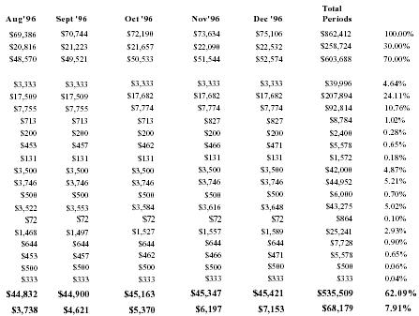
Aug '96 | Sept '96 | Oct '96 | Nov '96 | Dec '96 | Total Periods
$69,386 | $70,744 | $72,190 | $73,634 | $75,106 | $862,412 | 100.00%
$20,816 | $21,223 | $21,657 | $22,090 | $22,532 | $258,724 | 30.00%
$48,570 | $49,521 | $50,533 | $51,544 | $52,574 | $603,688 | 70.00%
$3,333 | $3,333 | $3,333 | $3,333 | $3,333 | $39,996 | 4.64%
$17,509 | $17,509 | $17,682 | $17,682 | $17,682 | $207,894 | 24.11%
$7,755 | $7,755 | $7,774 | $7,774 | $7,774 | $92,814 | 10.76%
$713 | $713 | $713 | $827 | $827 | $8,784 | 1.02%
$200 | $200 | $200 | $200 | $200 | $2,400 | 0.28%
$453 | $457 | $462 | $466 | $471 | $5,578 | 0.65%
$131 | $131 | $131 | $131 | $131 | $1,572 | 0.18%
$3,500 | $3,500 | $3,500 | $3,500 | $3,500 | $42,000 | 4.87%
$3,746 | $3,746 | $3,746 | $3,746 | $3,746 | $44,952 | 5.21%
$500 | $500 | $500 | $500 | $500 | $6,000 | 0.70%
$3,522 | $3,553 | $3,584 | $3,616 | $3,648 | $43,275 | 5.02%
$72 | $72 | $72 | $72 | $72 | $864 | 0.10%
$1,468 | $1,497 | $1,527 | $1,557 | $1,589 | $25,241 | 2.93%
$644 | $644 | $644 | $644 | $644 | $7,728 | 0.90%
$453 | $457 | $462 | $466 | $471 | $5,578 | 0.65%
$500 | $500 | $500 | $500 | $500 | $500 | 0.06%
$333 | $333 | $333 | $333 | $333 | $333 | 0.04%
$44,832 | $44,900 | $45,163 | $45,347 | $45,421 | $535,509 | 62.09%
$3,738 | $4,621 | $5,370 | $6,197 | $7,153 | $68,179 | 7.91%
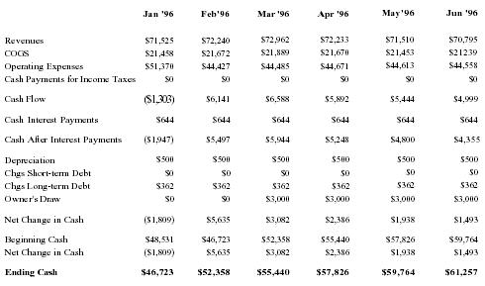
Projected Statement of Cash Flow Year Ending December 31, 1997
 | Jan '96 | Feb'96 | Mar '96 | Apr '96 | May '96 | Jun '96
Revenues | $71,525 | $72,240 | $72,962 | $72,233 | $71,510 | $70,795
COGS | $21,458 | $21,672 | $21,889 | $21,670 | $21,453 | $21,239
Operating Expenses | $51,370 | $44,427 | $44,485 | $44,671 | $44,613 | $44,558
Cash Payments for Income Taxes | $0 | $0 | $0 | $0 | $0 | $0
Cash Flow | ($1,303) | $6,141 | $6,588 | $5,892 | $5,444 | $4,999
Cash Interest Payments | $644 | $644 | $644 | $644 | $644 | $644
Cash After Interest Payments | ($1,947) | $5,497 | $5,944 | $5,248 | $4,800 | $4,355
Depreciation | $500 | $500 | $500 | $500 | $500 | $500
Chgs Short-term Debt | $0 | $0 | $0 | $0 | $0 | $0
Chgs Long-term Debt | $362 | $362 | $362 | $362 | $362 | $362
Owner's Draw | $0 | $0 | $3,000 | $3,000 | $3,000 | $3,000
Net Change in Cash | ($1,809) | $5,635 | $3,082 | $2,386 | $1,938 | $1,493
Beginning Cash | $48,531 | $46,723 | $52,358 | $55,440 | $57,826 | $59,764
Net Change in Cash | ($1,809) | $5,635 | $3,082 | $2,386 | $1,938 | $1,493
Ending Cash | $46,723 | $52,358 | $55,440 | $57,826 | $59,764 | $61,257
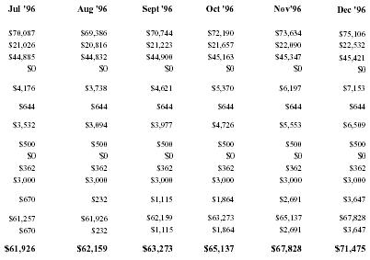
Jul '96 | Aug '96 | Sept '96 | Oct '96 | Nov'96 | Dec '96
$70,087 | $69,386 | $70,744 | $72,190 | $73,634 | $75,106
$21,026 | $20,816 | $21,223 | $21,657 | $22,090 | $22,532
$44,885 | $44,832 | $44,900 | $45,163 | $45,347 | $45,421
$0 | $0 | $0 | $0 | $0 | $0
$4,176 | $3,738 | $4,621 | $5,370 | $6,197 | $7,153
$644 | $644 | $644 | $644 | $644 | $644
$3,532 | $3,094 | $3,977 | $4,726 | $5,553 | $6,509
$500 | $500 | $500 | $500 | $500 | $500
$0 | $0 | $0 | $0 | $0 | $0
$362 | $362 | $362 | $362 | $362 | $362
$3,000 | $3,000 | $3,000 | $3,000 | $3,000 | $3,000
$670 | $232 | $1,115 | $1,864 | $2,691 | $3,647
$61,257 | $61,926 | $62,159 | $63,273 | $65,137 | $67,828
$670 | $232 | $1,115 | $1,864 | $2,691 | $3,647
$61,926 | $62,159 | $63,273 | $65,137 | $67,828 | $71,475

