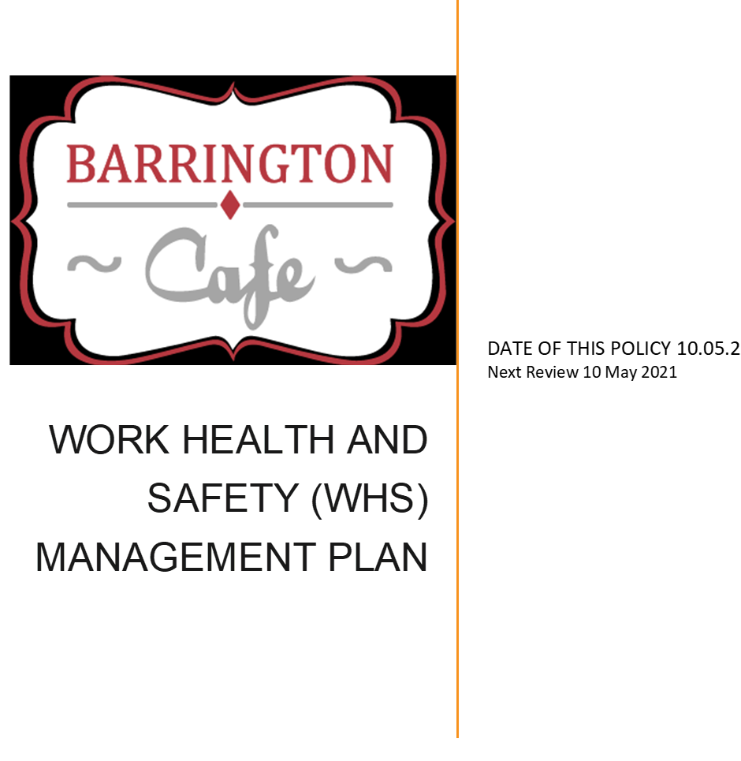

WORK HEALTH AND SAFETY (WHS)
POLICY STATEMENT
The health and safety of all staff, contractors, visitors and volunteers to Barrington Cafe (BC) is of utmost importance. It is BC’s policy that its workers shall be provided with a safe and healthy place in which to work, and that our work practices will not compromise the health or safety of others present at the workplace.
To achieve this policy BC implements a risk management approach to managing health and safety and makes every effort, where reasonably practicable, to eliminate or minimise risks associated with the workplace and the work performed by workers and volunteers. This will include considering health and safety matters in all organisational plans, procedures, programs and job instructions.

BC is committed to providing a safe work environment in accordance with relevant legislation and Australian Standards.

In conjunction with this policy, an integrated suite of policies, procedures, plans, positions and resources, form a comprehensive WHS Management System, that informs and directs operational practice. By approaching WHS in a systematic manner BC is better able to fulfil its commitment to continually improving health and safety performance and preventing workplace injury and illness.
Health and safety at work is both an individual and shared responsibility of all workers. Specific areas of responsibility are identified to ensure the success of this policy. BC is committed to effective consultation and engagement with workers in relation to WHS matters. We recognised that there are times that we share a primary duty of care with other duty holders regarding our workers (for e.g., contractors building owners/managers; other Person Conducting Business or Undertaking (PCBUs) when working offsite) and therefore we are committed to consult, cooperate and coordinate with other duty holders to produce the required health and safety outcomes.
BC is committed to ensuring that WHS related matters are effectively communicated to workers through a variety of avenues including for example, notice Managers, staff meetings, e-mails and our website.

CONTENTS

PART A: WORK HEALTH AND SAFETY ARRANGEMENTS 4
PURPOSE 5
WORK HEALTH AND SAFETY (WHS) POLICY 5
Statement of Commitment 5
Implementation of Policy Commitment 5
DEFINITIONS 6
RESPONSIBILITY 7
Office Manager 8
Managers and Leaders 9
Workers and Volunteers 9
Contractors 10
Visitors 10
CONSULTATION AND COMMUNICATION ARRANGEMENTS 10
Health and Safety Representatives 11
Health and Safety Committee 11
TRAINING 12
WHS RISK ASSESSMENT 12
AUTHORITATIVE SOURCES 13

PART A: WORK HEALTH AND SAFETY ARRANGEMENTS

PURPOSE
BC is committed to implementing a structured approach to workplace health and safety to achieve a consistently high standard of safety performance.

WORK HEALTH AND SAFETY (WHS) POLICY
The Statement of Commitment and the Implementation of Policy Commitment provide the overarching direction Soul Café will follow in pursuit of workplace health and safety outcomes.

Statement of Commitment
- BC is committed to providing a workplace that enables all work activities to be carried out safely.
- We will take all reasonably practicable measures to eliminate or minimise risks to the health, safety and welfare of workers, volunteers, contractors, visitors, and anyone else who may be affected by our operations.
- We are committed to ensuring we comply with the Work Health and Safety Act 2011 (the Act).
- We will also comply with any other relevant legislation, applicable Codes of Practice and Australian Standards as far as possible.

Implementation of Policy Commitment
BC is committed to ensuring, so far as is reasonably practicable, the health and safety of its workers (employees, contractors, labour hire workers, outworkers, apprentices, students or volunteers) while they are at work, and that the health and safety of other persons (e.g. visitors) is not put at risk from our operations. This will be achieved by,
  - Providing and maintaining a healthy and safe work environment through the implementation of safe work practices, safe systems of work, safe venue and equipment;
  - Routinely consulting to maintain effective and co-operative relationships between workers, volunteers and with other duty holders, on health and safety matters in the workplace;
  - Reviewing, through appropriate mechanisms, the effectiveness of the safety measures taken.
BC’s commitment to providing safe and healthy working environments for its workers includes,
    - Providing relevant, up to date WHS information to all workers on matters such as workplace safety and their responsibilities.
    - Providing expert assistance in WHS matters where necessary.

    - Providing instruction and/or training in work processes where appropriate and developing and implementing strategies which include workplace assessment, hazard identification, and appropriate remedial action to eliminate or control hazards.
    - Implementing and maintaining appropriate information, reporting and statistical systems.

DEFINITIONS

TERMINOLOGY | DEFINITION
Person Conducting a Business or Undertaking  (PCBU) | A PCBU has the primary duty of care to ensure, so far as is reasonably practicable:  - the health and safety of its workers while they are at work, and  - that the health and safety of other persons is not put at risk from work carried out as part of the conduct of the PCBU.  - BC is a PCBU.
Officer
It is an officer's duty to exercise due diligence to ensure that the PCBU complies with its health and safety obligations under the WHS
- The Members of the Manager for BC will usually be Officers under the WHS Act.
- The Office Manager may be an Officer under the WHS Act
Note: A person is an Officer under the WHS Act only if they “make, or participate in making, decisions that affect the whole, or a substantial part, of the business of the corporation; or who has the capacity to affect significantly the corporation's financial standing”. Whether a person is an Officer or not under the WHS Act will
depend on the facts of the particular situation.
Worker | Previously known as 'employee'. The term worker includes employees, contractors and sub-contractors and their employees, labour hire employees, outworkers, apprentices and trainees, work experience students and volunteers.
Health and Safety Representative (HSR) | A worker elected by members of their work group to represent them in health and safety matters.
Attending Service | Persons representing other services that attend BC to provide services to the BC  guests (e.g. Centrelink, Hairdressers, doctors).

Guests | Persons attending the café who are in need (eg. Addictions, mental health, poverty,  social isolation).
Other persons | Includes any visitors

RESPONSIBILITY
As the duty holder, BC being the PCBU, must:
  - ensure the health and safety of its workers and others in our workplace
  - ensure the health and safety of other persons is not put at risk from work carried out as part of its operations
  - provide and maintain a work environment that is without risks to health and safety
  - provide and maintain a safe venue equipment and structures
  - provide and maintain safe systems of work
  - ensure the safe use, handling and storage of equipment and substances
  - provide adequate facilities for the welfare of workers
  - provide information, training, instruction and supervision
  - monitor the health of workers and the conditions of our workplaces. Specific duties as a PCBU also include:
  - record and notify BC of any notifiable incidents arising out of the conduct of the business or undertaking
  - ensure authorisations are in place for any high-risk work
  - consult as far as reasonably practicable with other PCBU’s or persons who have a duty
regarding work health and safety matter.
  - consult as far as reasonably practicable with worker, their representatives and Health and Safety representative on work health and safety matters.

Office Manager
The Office Manager (if an officer), is responsible for ensuring that procedures are implemented in the workplace and/or systems of work under their control. As an integral part of their normal duties, the Office Manager will,
  - consult with their workers on measures to protect their health and safety
  - actively follow agreed safety practices and model positive attitudes towards health and safety matters
  - arrange for their workers to be instructed in healthy and safe systems of work and procedures and supervise the practice of safe working procedures
  - notify the Chairperson and/or other members of the Manager of all incidents, hazardous situations, dangerous occurrences or immediate risks to health and safety of any workers
  - ensure that all workers are informed of this policy
  - undertake consultation with all managers and workers on change that may affect their health and safety
  - ensure that WHS is a standing agenda item at all staff meetings
  - communicate WHS matters to the Chairperson of the Manager.

Managers and Leaders
Managers and leaders are responsible for providing a workplace that is, as far as reasonably practicable, safe and healthy workplace for workers and visitors, in the areas of their control. This includes,
  - modelling health and safety leadership
  - demonstrating a commitment to good health and safety performance, by:
  - talking about safety at regular meetings
  - ensuring safe work procedures are followed
  - reporting incidents, hazards and safety concerns promptly
  - assessing task risk and not allowing an activity to continue until it can be controlled adequately
  - actively support the identification of hazards and risks and the management of these
  - understand and monitor safety performance objectives
  - proactively manage other duty holders (e.g. contractors), when required.

Workers and Volunteers
Workers and volunteers must take reasonable care for their own health and safety while they are at work and take reasonable care that their acts or omissions do not adversely affect the health and safety of other persons. They must comply, so far as they are reasonably able, with any reasonable instruction given by the office Manager, as well as co-operating with any reasonable BC policy or procedure which relates to workplace health and safety. On a day to day basis this includes to the extent of the worker/volunteer's control or influence over working conditions and methods,

  - to take reasonable care to work safely
  - making sure that the work area safe when leaving it
  - make proper use of all appropriate safeguards, safety devices and personal protective equipment
  - follow agreed safe working practices and rules
  - report all known hazards, accidents and incidents as soon as possible.
It is acknowledged that, in accordance with the Act, a worker may cease, or refuse to carry out work if they have a reasonable concern the work would expose the worker to a serious risk to their health or safety. The Act requires workers who cease work to notify the relevant manager that they have ceased unsafe work as soon as practicable after doing so. It also requires workers to remain available to carry out 'suitable alternative work'. This would not however require workers to remain at any place that poses a serious risk to their health or safety.

Contractors
Contractors, sub-contractors and self-employed persons are defined as “workers” under the WHS
Act if they carry out work in any capacity for BC. They are required to,
  - comply with the requirements of the WHS legislation
  - have in place any work health and safety policies and programs required under state or Territory safety legislation
  - consult with BC about safety matters and comply with BC policies
  - work safely and to include safety of staff and visitors in the plans
If any staff member believes that a contractor may be engaging in an unsafe work practice, they are required to report this issue to their manager.

Visitors
Visitors and other person to BC also have responsibilities to abide by our workplace safety rules and procedures. These responsibilities include to,
  - take reasonable care for their own health and safety and for the health and safety of other persons
  - comply with so far as they are reasonably able, all reasonable safety directions provided by BC staff
  - report all safety related incidents to BC staff
  - ensure adequate supervision of any accompanying children
  - not to enter any restricted area without authorisation or escorts
  - not bring or consume alcohol or illegal drugs at workplaces
  - not willfully or recklessly interfere with BC property

CONSULTATION AND COMMUNICATION ARRANGEMENTS
Open communication between workers, volunteers and team leaders / managers is important to ensuring a safe workplace. Therefore, workers and volunteers are encouraged to,
  - ask questions relating to WHS
  - bring up safety concerns
  - make recommendations regarding WHS
  - give regular feedback
  - become involved in evaluation of safety issues
  - participate in any WHS related problem-solving process.
It is important that workers and volunteers help shape decisions about WHS particularly when:
  - identifying hazards and assessing risks

  - making decisions about ways to eliminate or minimise those hazards or risks
  - proposing business changes that may affect the health and safety of workers
  - purchasing of new equipment or substances
  - developing or changing job tasks or safety procedures.
  - All workers and volunteers belong to a team and are encouraged to raise any work health and safety concerns they may have with their team leader / manager and/or Health and Safety Representatives (HSR).

Health and Safety Representatives
HSRs are elected by members of a team to represent the interests of that work group in matters relating to work health and safety. HSRs must undertake approved training to exercise their powers, and may,
  - consult with workers / volunteers on a regular basis
  - inspect a work area as required
  - participate in workplace accident and incident investigations as required
  - participate in any change management discussion’s that may affect the health and safety
  - provide advice to team leaders / managers on the welfare of their group.

HSRs cannot exercise their powers under the Act unless they are trained. HSRs are not liable for acts or omissions that are undertaken in good faith. HSRs are not entitled to personal or medical information about a worker without their consent unless that information is of a general form that does not identify workers specifically.

Health and Safety Committee
Health and safety committees provide the forum for the constructive discussion of measures to assure health and safety in the workplace. At BC the health and safety committee will meet quarterly and facilitate co-operation between the PCBU and workers in the instigation, development and implementation of WHS policies and procedures. They will,
  - assist in developing standards, rules and procedures relating to health and safety
  - consult with workers / volunteers regarding their WHS concerns
  - consult with management regarding worker / volunteer WHS concerns including change that may influence WHS more broadly
  - ensure the conduct of regular workplace inspections.
  - minutes of the latest Health and Safety Committee meeting will be made available for all workers / volunteers to review.

TRAINING
The office Manager will conduct a training needs analysis and arrange for appropriate WHS training to be undertaken by workers as required. Where required BC workers / volunteers are to demonstrate their competencies to perform required task safely. In tasks with a high potential for injury, a separate documented assessment of a person's competency may be undertaken. As a guide, competency assessments should be signed and dated by the assessor/assessee and contain the following elements,
  - task or equipment description
  - information on licenses held (or other relevant qualifications)
  - a checklist containing the essential competencies that were demonstrated, and
  - comments or confirmation that the competency was met
BC is committed to developing a suite of competencies to deal with all safety sensitive work tasks.

WHS RISK ASSESSMENT
The purpose of any WHS risk assessment is to ensure that, for any identified hazards, appropriate control measures are implemented to protect workers, contractors and visitors from risks to their health, safety and welfare. Control measures for WHS hazards should be implemented as required using the following hierarchy of control, in order of preference these measures relate to,
  - elimination (removal of the hazard)
  - substitution (substitute the hazard for something which is less hazardous e.g. replace a hazardous chemical with one within is not hazardous)
  - isolation (isolate the hazard from people e.g. place a noisy piece of equipment in another location)
  - engineering (e.g. guarding on machinery)
  - administrative (e.g. provision of training, policies and procedures, signage)
  - personal protective equipment (e.g. use of hearing, eye protection, high visibility vests).

Outcomes of risk assessments will be documented, and the control measures reviewed at least annually or earlier should a task or activity be the subject of a WHS incident or a change of process or requirement. Current risk assessments will ensure that the goal of eliminating or minimising the risk workers may be exposed to has been achieved.

WHS ISSUE RESOLUTION
Wherever possible, any WHS concerns will be resolved through consultation between workers / volunteers, their representatives and/or their manager. If the concern cannot be resolved, then it can be referred to the office Manager for resolution. Ultimately any issue remaining unresolved may be referred to the Manager. Where the issue remains unresolved the default procedure for issue resolution set out in the WHS Regulations must be followed. If reasonable efforts have been made to resolve an issue and it remains unresolved, any party to the issue can ask BC to appoint an inspector to assist in resolving the matter.

AUTHORITATIVE SOURCES
Work Health and Safety Act 2011
Work Health and Safety Regulation 2011
Approved Work Health and Safety Codes of Practice

